**Lab Number: 03**

**RMI CALLBACK**

1. **Develop the RMI Callback application of Payroll and PayrollMessage services for calculating the earnings.**

**Client Side**

**Interface**

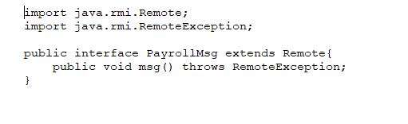

**Remote Class**

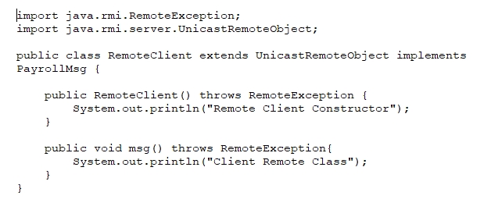

**Client Main Class**

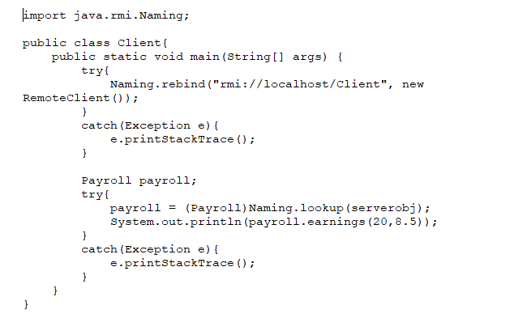

**Server Side**

**Interface**

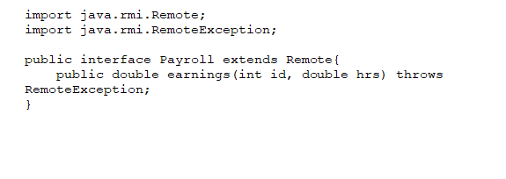

**Remote Class**

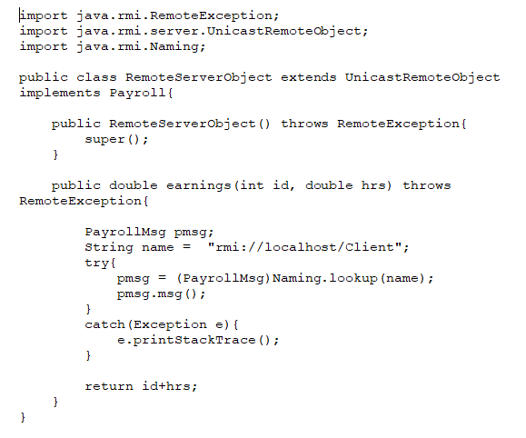

**Server Main Class**

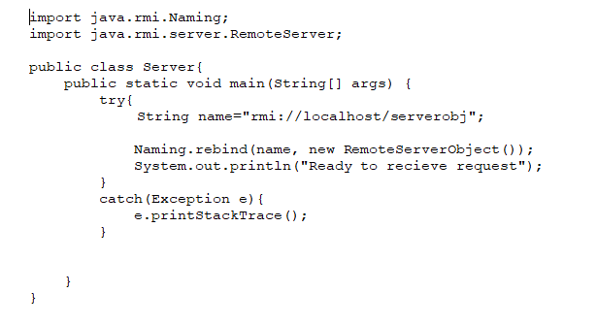

**Output**

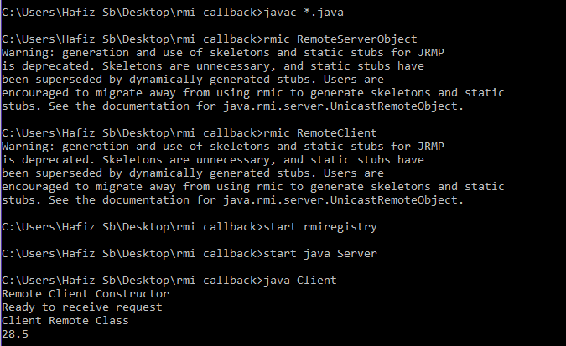

1. **Optional Task: Develop an RMI application for chatting between client and server , the chatting should stop when both of them say “bye”.**

**Client Side**

**Interface:**

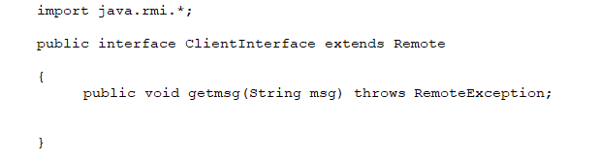

**Main Class:**

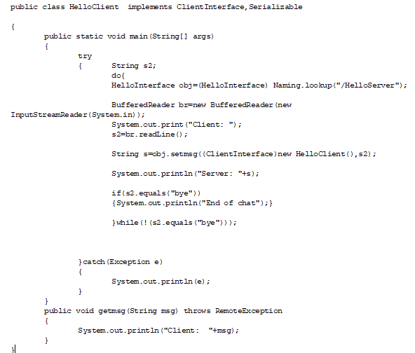

**Server Side**

**Interface:**

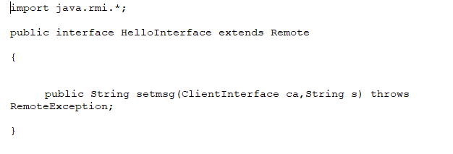

**Remote Class**

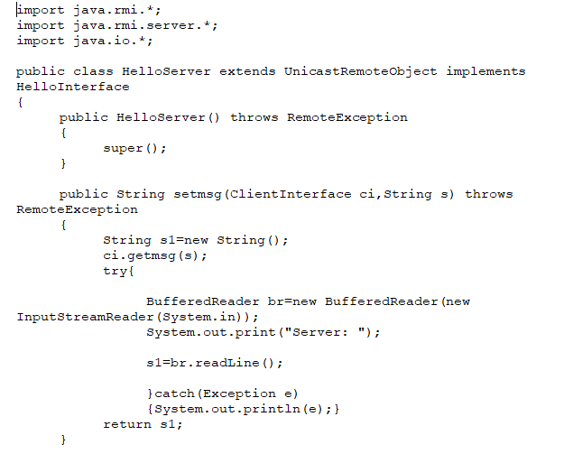

**Main Class:**

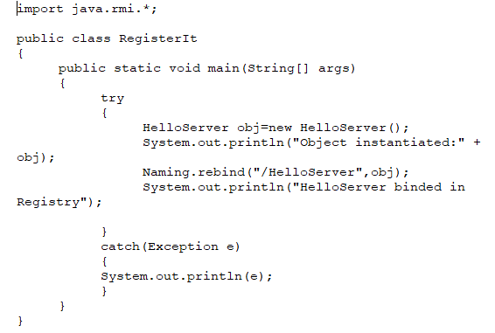

**Output**

